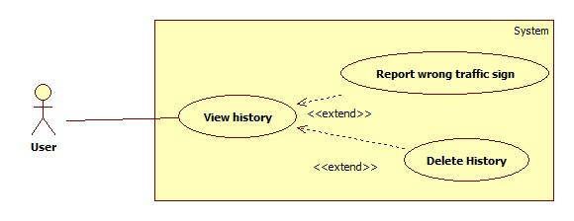

|  |  |  |  |
| --- | --- | --- | --- |
| **USE CASE –** | | | |
| **Use Case No.** |  | **Use Case Version** | 1.0 |
| **Use Case Name** | View history | | |
| **Author** | Mai Van Tan | | |
| **Date** | 15/01/2014 | **Priority** | Normal |
| **Actor:** User  **Summary:**   * User use this case to view history, delete history and report wrong traffic sign   **Goal:**   * Allow user to view search history   **Triggers:**   * User login their account in webpage or mobile app, then go to the View history Item.   **Preconditions:**   * User must login.   **Post Conditions:**   * **Success**: The search history will be listed in the screen. * **Fail:** The system redirect to the error page.   **Main Success Scenario:**   |  |  |  | | --- | --- | --- | | Step | Actor Action | System Response | | 1 | User clicks to view history item. | System will show the list search history to screen. |   **Alternative Scenario:** N/A  **Exceptions:**   |  |  |  | | --- | --- | --- | | No | Actor Action | System Response | | 1 | User is not login. | System show the message to ask user login before view history. |   **Relationships: N/A**  **Business Rules: N/A** | | | |



|  |  |  |  |
| --- | --- | --- | --- |
| **USE CASE –** | | | |
| **Use Case No.** |  | **Use Case Version** | 1.0 |
| **Use Case Name** | Delete history | | |
| **Author** | Mai Van Tan | | |
| **Date** | 15/01/2014 | **Priority** | Normal |
| **Actor:** User  **Summary:**   * User uses this case to delete search history.   **Goal:**   * Allow user deletes their search history.   **Triggers:**   * User clicks on the delete item of the history item.   **Preconditions:**   * User must login.   **Post Conditions:**   * **Success**: The history is deleted from history list. * **Fail:** Show the error to user.   **Main Success Scenario:**   |  |  |  | | --- | --- | --- | | Step | Actor Action | System Response | | 1 | User clicks on view history item. | System will show the list search history to screen. | | 2 | User clicks on delete item of history item. | System show the message “Delete successful” then refresh the list history. |   **Alternative Scenario:** N/A  **Exceptions:**   |  |  |  | | --- | --- | --- | | No | Actor Action | System Response | | 1 | Cannot delete history. | Show message: “Delete fail”. |   **Relationships: N/A**  **Business Rules: N/A** | | | |

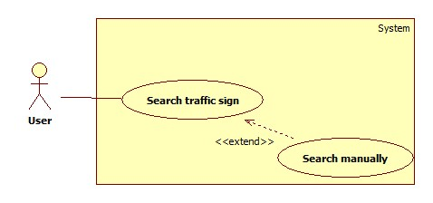

|  |  |  |  |
| --- | --- | --- | --- |
| **USE CASE –** | | | |
| **Use Case No.** |  | **Use Case Version** | 1.0 |
| **Use Case Name** | Search traffic sign in manually | | |
| **Author** | Mai Van Tan | | |
| **Date** | 15/01/2014 | **Priority** | Normal |
| **Actor:** User  **Summary:**   * User uses this case to search traffic sign in manually.   **Goal:**   * Allow user search traffic sign in manually.   **Triggers:**   * User clicks on search manually item.   **Preconditions:** N/A  **Post Conditions:**   * **Success**: The information of the traffic sign. * **Fail:** No traffic sign is found.   **Main Success Scenario:**   |  |  |  | | --- | --- | --- | | Step | Actor Action | System Response | | 1 | User clicks on search history item. | Show the search history screen:   * A textbox to input text. * A search button. * A list contain of main type traffic sign. | | 2 | User clicks on a type of traffic sign | Show the list of traffic sign in selected type. | | 3 | User clicks on a traffic sign item | Show the information of the traffic sign |   **Alternative Scenario:**   |  |  |  | | --- | --- | --- | | Step | Actor Action | System Response | | 1 | User clicks on search history item. | Show the search history screen:   * A textbox to input text. * A search button. * A list contain of main type traffic sign. | | 2 | User input key work and press search button | Show the list of traffic sign match result  [Exception 1] | | 3 | User clicks on a traffic sign item | Show the information of the traffic sign |   **Exceptions:**   |  |  |  | | --- | --- | --- | | No | Actor Action | System Response | | 1 | Not traffic sign match with the key work | Show message “No match” |   **Relationships: N/A**  **Business Rules: N/A** | | | |

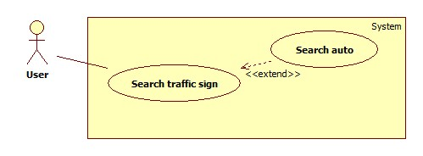

|  |  |  |  |
| --- | --- | --- | --- |
| **USE CASE –** | | | |
| **Use Case No.** |  | **Use Case Version** | 1.0 |
| **Use Case Name** | Search auto | | |
| **Author** | Mai Van Tan | | |
| **Date** | 15/01/2014 | **Priority** | High |
| **Actor:** User  **Summary:**   * User uses this case to make auto search.   **Goal:**   * Allow user auto search a traffic by take a photo or upload a photo.   **Triggers:**   * User clicks on the auto search item.   **Preconditions:**  **Post Conditions:**   * **Success**: Show the information of the traffic sign. * **Fail:**   **Main Success Scenario:**   |  |  |  | | --- | --- | --- | | Step | Actor Action | System Response | | 1 | User click on auto search item. | System will show a screen contain:   * Button to take camera picture (only in mobile version) * Button to select image file * Submit button | | 2 | User click on take camera picture | System show the camera screen that allow user take a picture | | 3 | User submit the picture | System show message “Submit successful”  [Exception 1] | | 4 |  | System notify to user to view the result | | 5 | User click to view result | System show the screen contain:   * The submitted picture * The list result of search   [Exception 2] | | 6 | User click to the result item | System show the traffic sign information |   **Alternative Scenario:**   |  |  |  | | --- | --- | --- | | Step | Actor Action | System Response | | 1 | User click on auto search item. | System will show a screen contain:   * Button to take camera picture (only in mobile version) * Button to select image file * Submit button | | 2 | User click on select image file | System show select image file windows | | 3 | User select image and click submit button | System show message “Submit successful” | | 4 |  | System notify to user to view the result | | 5 | User click to view result | System show the screen contain:   * The submitted picture * The list result of search   [Exception 2] | | 6 | User click to the result item | System show the traffic sign information |   **Exceptions:**   |  |  |  | | --- | --- | --- | | No | Actor Action | System Response | | 1 | User in mobile and not have internet connection | Show message “No internet connection, auto submit image when internet available” | | 2 | No result found | Show message “No result found” suggest user to user manually search or make an auto search again |   **Relationships: N/A**  **Business Rules: N/A** | | | |
|  | | | |